SpectralWeather
User manual for the layer workspace
Version 0.48 • 17 October 2026
This manual explains the interface, from selecting layers and dates to comparing maps, calculating plots and exporting a study. Its interface illustrations are captures of the application. The wave figures illustrate OLR and filtered tropical waves. A complete reference covers the header, left-hand controls and dialogs.
Open SpectralWeather
Table of Contents
Before you begin 2
1 Start a study in the layer workspace 2
2 Configure each field 3
3 Compare layers on one or two maps 5
4 Choose rainfall and atmospheric fields 6
5 Use backgrounds and reference reports 7
6 Load and adapt prepared examples 8
7 Play dates and prepare responses 9
8 Calculate regional plots 10
9 Select OLR and filtered wave fields 11
10 Configure trajectories 12
11 Use the independent Wave Hovmöller 14
12 Save and transfer settings 14
13 Export a map figure 15
14 Reset the study and open documentation 16
15 Complete interface reference 18
15 1 Header categories 18
15 2 Header actions and time 19
15 3 Left hand workspace controls 19
15 4 Field settings in detail 20
15 5 Track settings in detail 21
15 6 Map interactions and dialogs 21
16 Scientific interpretation and wave figures 22
Total OLR anomaly 23
CCKW filtered OLR 24
ER filtered OLR 25
MJO filtered OLR 26
17 Scientific figure recipes 27
17.1 Compare two maps fairly 27
17.2 Look for rain before the water response 28
17.3 Follow one region through time 28
17.4 Read a wave diagram one ingredient at a time 29
17.5 Distinguish a position a path and an extent 30
17.6 Save enough information to repeat the study 30
18 Sources 31
19 Software and architecture 31
Browser workspace 31
Cloud services and data paths 31
Plotting and requirements 32
20 Data and scientific methods 32
20 1 Earth Engine and the community catalogue 32
20 2 CYGNSS fractional inundation 32
20 3 Spatial flood candidates 33
20 4 Temporal links and event components 34
20 5 ERA5 and radiation inputs 35
20 6 Seasonal anomalies and spectral filtering 35
20 7 Detecting and linking wave tracks 36
20 8 Animated winds and wind speed 37
20 9 Averaging anomalies and regional plots 37
20 10 Catchments reports and scientific interpretation 38
21 Methods references 38
22 DFO flood reports and CYGNSS comparisons 38

Before you begin
Start with a question, such as “Did surface water increase after the rain?” Open Examples, choose a case, and change one setting at a time. Chapters 1–14 explain the controls; chapter 17 walks through illustrated recipes. Chapters 19–20 explain how the application and its calculations work.
A field is a set of values across a map, such as rainfall. A layer is that field or another item placed on the map. Layers can be stacked like transparent sheets. The legend tells you what their colours and numbers mean.
A pixel or grid cell represents an area, not a single point. Water fraction describes how much of that area is covered by water: 0.20 means 20%. It does not tell you the water depth. A candidate is something the computer flagged for further checking, not a confirmed flood.
An anomaly is a departure from a usual or reference value. Its meaning depends on the dataset. A window is the period included in a calculation. A mean is an average; an accumulation adds amounts over time. Read the dates and units before comparing two results.
OLR means outgoing longwave radiation: heat energy leaving Earth towards space. High, cold tropical clouds often reduce this energy. Filtering separates broad moving cloud patterns into bands called MJO, CCKW and ER. These are large atmospheric patterns, not individual storms. Lower filtered OLR often points to a more active cloudy phase; it does not measure moisture directly.
MJO is the Madden–Julian Oscillation, a slowly moving tropical pattern; CCKW means convectively coupled Kelvin wave, an eastward-moving pattern linked to deep cloud activity; ER means equatorial Rossby wave, usually moving westward. A trajectory joins successive detected positions. Blank map areas can mean missing observations, so never assume that blank means dry.

1 Start a study in the layer workspace
SpectralWeather compares CYGNSS surface-water products with rainfall, atmospheric and land fields, reference reports and tropical-wave diagnostics. The interface uses a stack of named layers. Choose a category in the header, expand Select fields and tick the variables you need. Changing the category filters the choices; it does not remove selected layers.
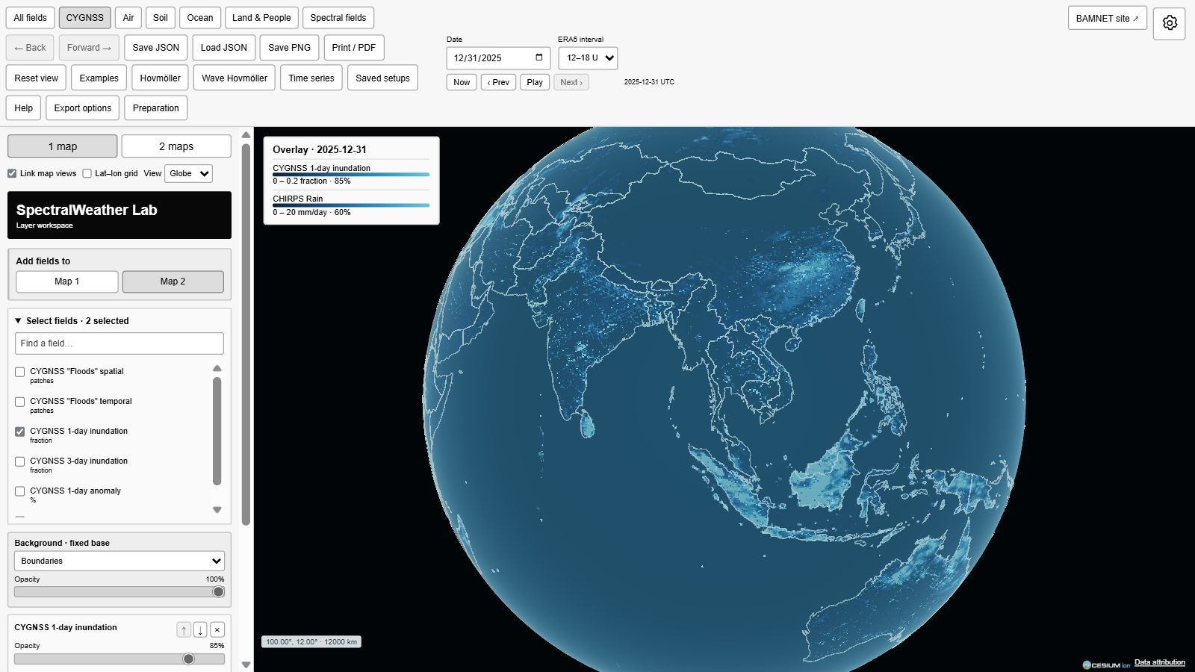
Figure 1. Start a study in the layer workspace.
Set Date in the header, then wait until the loading message clears. Selected layers load automatically. Each layer has its own opacity and expandable settings. The legend identifies the displayed variable, date, scale and opacity. Use earth − to collapse the controls and earth + to bring them back.
For a guided start, open Examples and choose a prepared case. Back to controls returns from the example view to its editable workspace.

2 Configure each field
Expand Field settings on a layer card. Follow uses the header date; Fixed holds the layer on a chosen date. Days before offsets its date relative to the header. Window selects the trailing calculation period, including its end date. Calculate chooses mean, minimum or maximum; rainfall also supports accumulation.
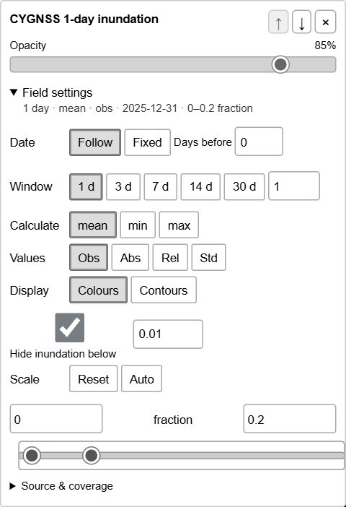
Figure continues below.
Figure 2. Configure each field.
The product name and calculation window have different meanings. CYGNSS 3-day inundation is already a rolling product; choosing a 1-day window displays that product for one date. A longer Window aggregates successive product dates and does not turn them into independent daily observations.
Values selects observations or an available anomaly representation. Display chooses colours or contours where supported. Scale changes colour limits, not measurements. Auto fits valid values in the visible region; Reset restores defaults. Hide inundation below makes low observed fractions transparent: 0.01 means 1%. Expand Source & coverage for dataset details. Scroll the controls to reach lower settings.

3 Compare layers on one or two maps
Choose 1 map for overlays or 2 maps for a side-by-side comparison. Link map views synchronizes their camera positions. Globe and Lat–lon select the projection; Lat–lon grid adds coordinate references.
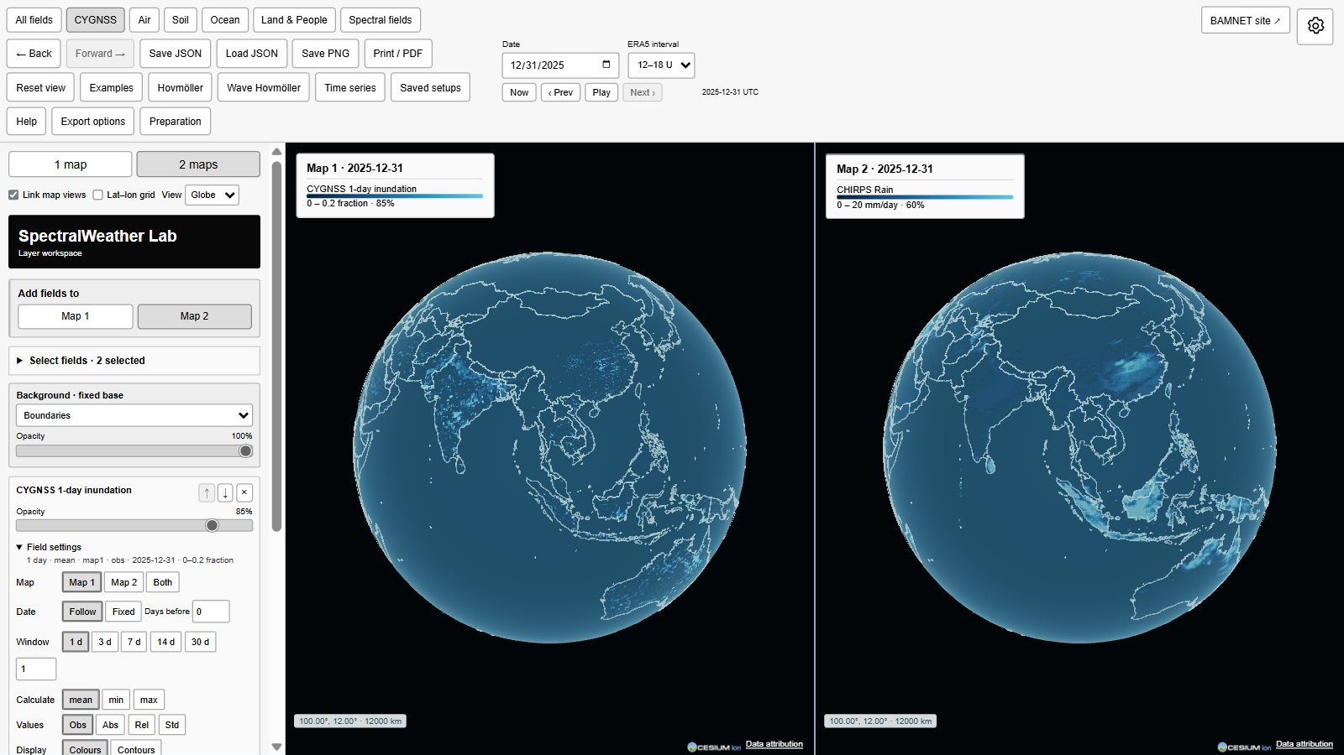
Figure 3. Compare layers on one or two maps.
Add fields to chooses the destination for newly selected fields. It does not move existing layers. In two-map mode, open a layer’s settings and choose Map 1, Map 2 or Both to change its assignment. Each map has its own legend.
Use the up and down arrows to reorder layers. The topmost fully opaque colour layer can hide a lower one. Reduce its Opacity, remove it temporarily, use separate maps or use contours where available. Blended colours do not define a new physical quantity. Read each variable from its own legend and units.

4 Choose rainfall and atmospheric fields
In Air, search for rain. CHIRPS and IMERG provide separate rainfall choices. The 1-day rain preset shows the header date. Last 3 days of rain and Last 7 days of rain select accumulated rainfall ending on that date. These presets change only the chosen rainfall layer, leaving other layers’ dates and windows intact.
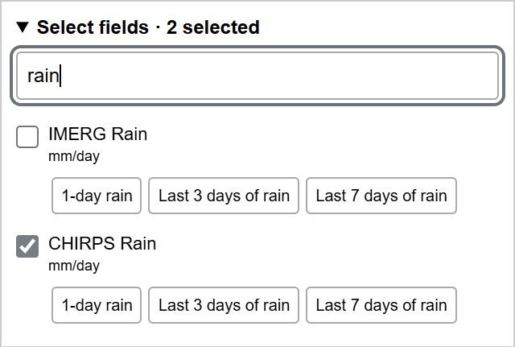
Figure 4. Choose rainfall and atmospheric fields.
Check the legend carefully: a daily rate uses mm/day, while an accumulated window uses mm. The displayed start and end dates belong to that layer. Comparing rain before inundation requires an explicit date offset or separate window; opacity does not introduce a time lag.
Air also includes wind, temperature, humidity, dew point and sea-level pressure. Level selects Surface or a supported pressure level. A pressure level is not a fixed height above the terrain. ERA5 Wind animation is a separate particle layer, so its level can differ from a temperature or humidity field.

5 Use backgrounds and reference reports
Background stays below the field stack. Boundaries provides a geographic reference; OpenStreetMap shows mapped roads and places; Esri imagery shows satellite and aerial mosaics; Terrain uses shaded relief; Black uses a plain black background. Changing the study date does not select imagery acquired on that date.
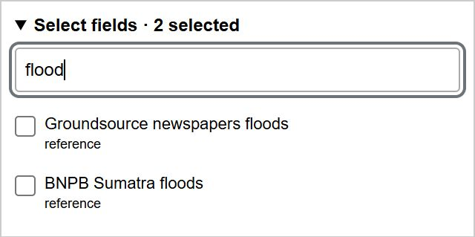
Figure 5. Use backgrounds and reference reports.
Land & People contains HydroSheds Rivers, JRC permanent water, Groundsource newspapers floods, BNPB Sumatra floods and Sumatra newspapers. Add these as named layers. HydroSHEDS shows static major river channels; permanent water is a historical JRC reference, not current inundation.
Groundsource polygons locate places mentioned in newspaper reports, not measured flood footprints. BNPB and Sumatra newspaper circles group records at district centres. Inspect a marker to read its records. A common district and date do not prove that two sources describe the same event. Missing reports do not establish that no flood occurred.

6 Load and adapt prepared examples
Examples loads a programmed date, region and set of layers. Cases include Sumatra flood reports for 9 March 2023, the Okawango delta in 2022, Eastern Australia in 2022, and North Sumatra in November 2025. The time-series choices prepare a plot; select Plot to calculate it.
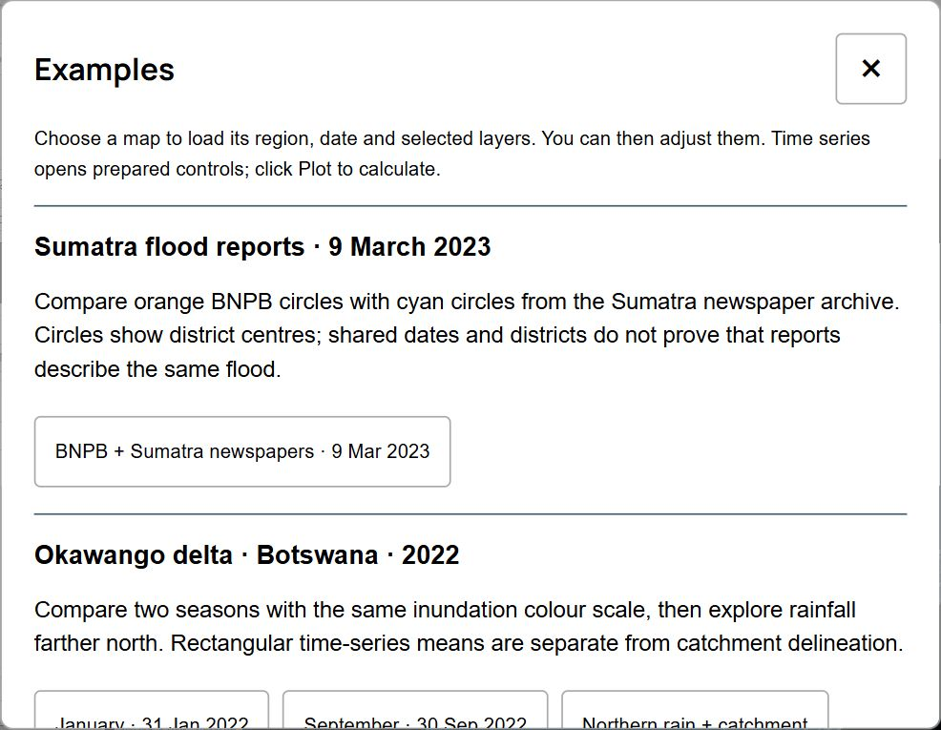
Figure 6. Load and adapt prepared examples.
Use Back to controls to edit a loaded case. Other examples returns to the case list. The browser address identifies the selected prepared case. Copy that address to share the programmed example. It does not transmit later unsaved edits or another browser’s local saved setups.
CYGNSS Spatial and Temporal layers show algorithm candidates. Filled green and orange circles mark candidate anchors, not their full area or independently confirmed floods. Temporal candidates participate in accepted links across nearby dates. Report overlap is supporting context, not independent proof of the candidate footprint.

7 Play dates and prepare responses
Date is the UTC end date. Prev and Next normally advance one day. With a following ERA5 trajectory layer, they advance one six-hour interval; the labels show 6 h. ERA5 interval selects 0–6, 6–12, 12–18 or 18–24 UTC. Other datasets keep their own temporal resolution. Now goes to the archive’s latest available date, not today.
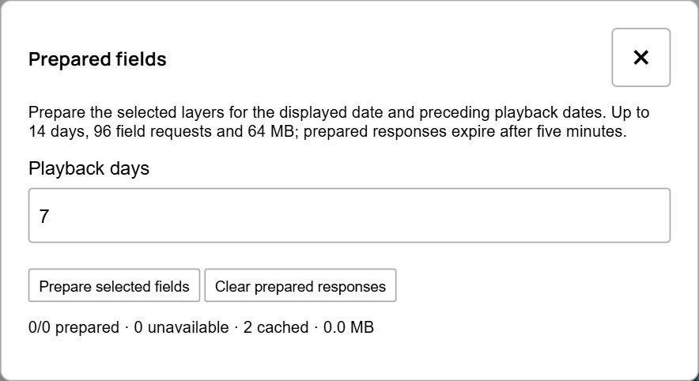
Figure 7. Play dates and prepare responses.
Play advances after the selected layers load. Fixed layers keep their dates; following layers use the moving header date and their own Days before offsets. Pause before changing a study you want to inspect closely.
Preparation opens Prepared fields. Choose Playback days and Prepare selected fields to cache responses for the displayed date and preceding dates. Limits are 14 days, 96 requests and 64 MB; responses expire after five minutes. The status distinguishes prepared, unavailable and cached responses. This temporary cache is not a saved dataset archive.

8 Calculate regional plots
Hovmöller and Time series use the first two visible, eligible numerical fields from the workspace. In the plot dialog they are named Field1 and Field2; these names describe plot inputs. Candidate catalogues, categorical fields and static reference layers are excluded.
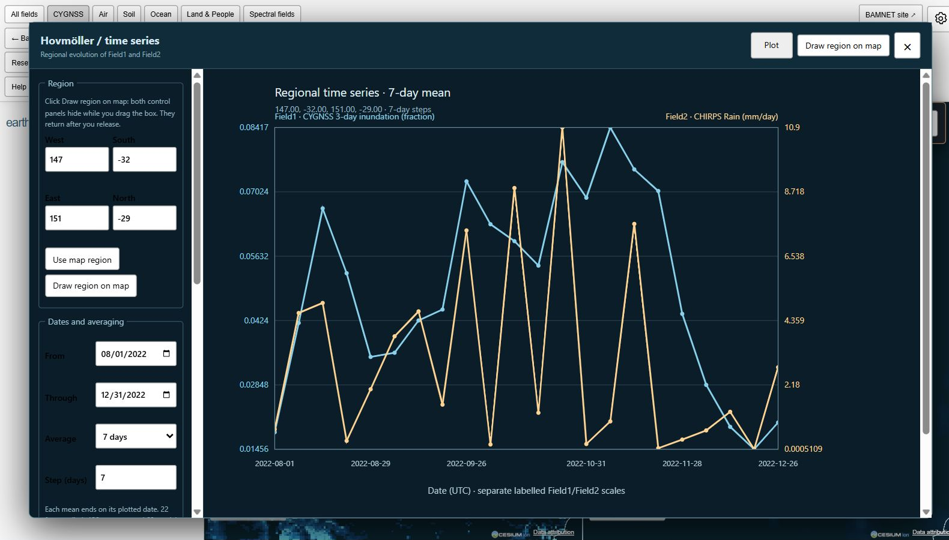
Figure 8. Calculate regional plots.
Set West, South, East and North, or use Draw region on map. Choose From, Through, Average and Step, then Plot. Direction selects longitude–time, latitude–time or regional time series. The dialog shows its frame limit; increase Step for a long date range. Each mean ends on its plotted date.
The screenshot shows the completed Eastern Australia example: 147–151°E, 32–29°S, 1 August–31 December 2022, seven-day means and a seven-day step. CYGNSS 3-day inundation and CHIRPS rainfall use separate axes. Coverage notes describe valid sampled area, not the number of observed days. Missing coverage stays blank. Download SVG saves the figure; time series also offers CSV.

9 Select OLR and filtered wave fields
Spectral fields provides ERA5 total OLR and CCKW-, MJO- and ER-filtered OLR. OLR is outgoing longwave radiation at the top of the atmosphere, in W/m². Negative filtered OLR commonly indicates enhanced deep convection; it is not a direct measurement of rainfall or flooding.
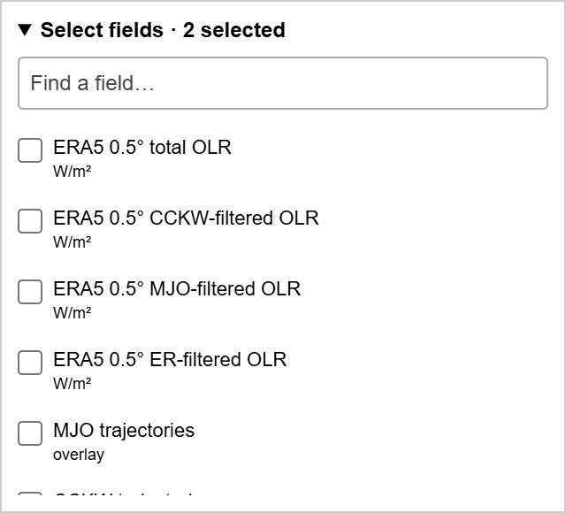
Figure 9. Select OLR and filtered wave fields.
The default ERA5 archive uses 0.5° six-hour means across 20°S–20°N during 2018–2025. A retained 0.25° legacy archive is separate. ERA5 is a reanalysis. NOAA daily satellite OLR is a distinct source; matching dates do not make these archives interchangeable.
Select scalar wave fields independently from trajectory layers. Each selected field retains its own date, window, display and scale. Seasonal OLR ITCZ axes are a repeated climatological convection proxy, not observed daily ITCZ locations.

10 Configure trajectories
Add MJO trajectories, CCKW trajectories or ER trajectories under Spectral fields, then expand Track settings on the layer card. Choose its map assignment, Follow or Fixed date, source, trail length, minimum OLR amplitude and optional Lat–lon extent. Source availability depends on the wave family.
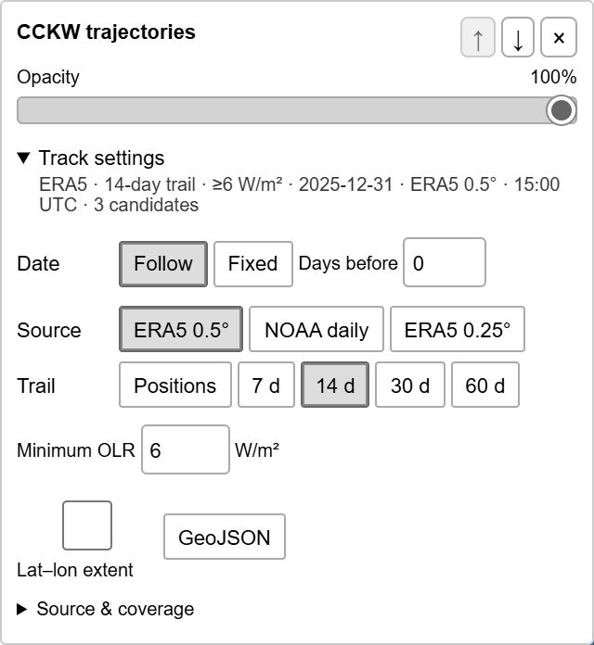
Figure 10. Configure trajectories.
Positions shows current detections; a trail adds their preceding paths. The amplitude threshold filters the display and does not recalculate the tracking algorithm. Extent boxes describe detected patch latitude and longitude limits on the selected date; they are not forecasts or uncertainty bounds. GeoJSON exports the displayed geometry.
Tracks are OLR-based candidates in the equatorial detection belt. A path is not an independently confirmed wave or flood, and split/merge ambiguity remains. The trajectory source and the scalar OLR source can differ. Check both before interpreting apparent displacement.

11 Use the independent Wave Hovmöller
Wave Hovmöller has its own controls, independent of the map’s layers. Select the ERA5 dataset, dates, longitude range, daily or six-hour sampling, shading field, latitude band and contour levels. Each wave contour has an independent latitude band and levels. Time runs downwards and longitude horizontally.
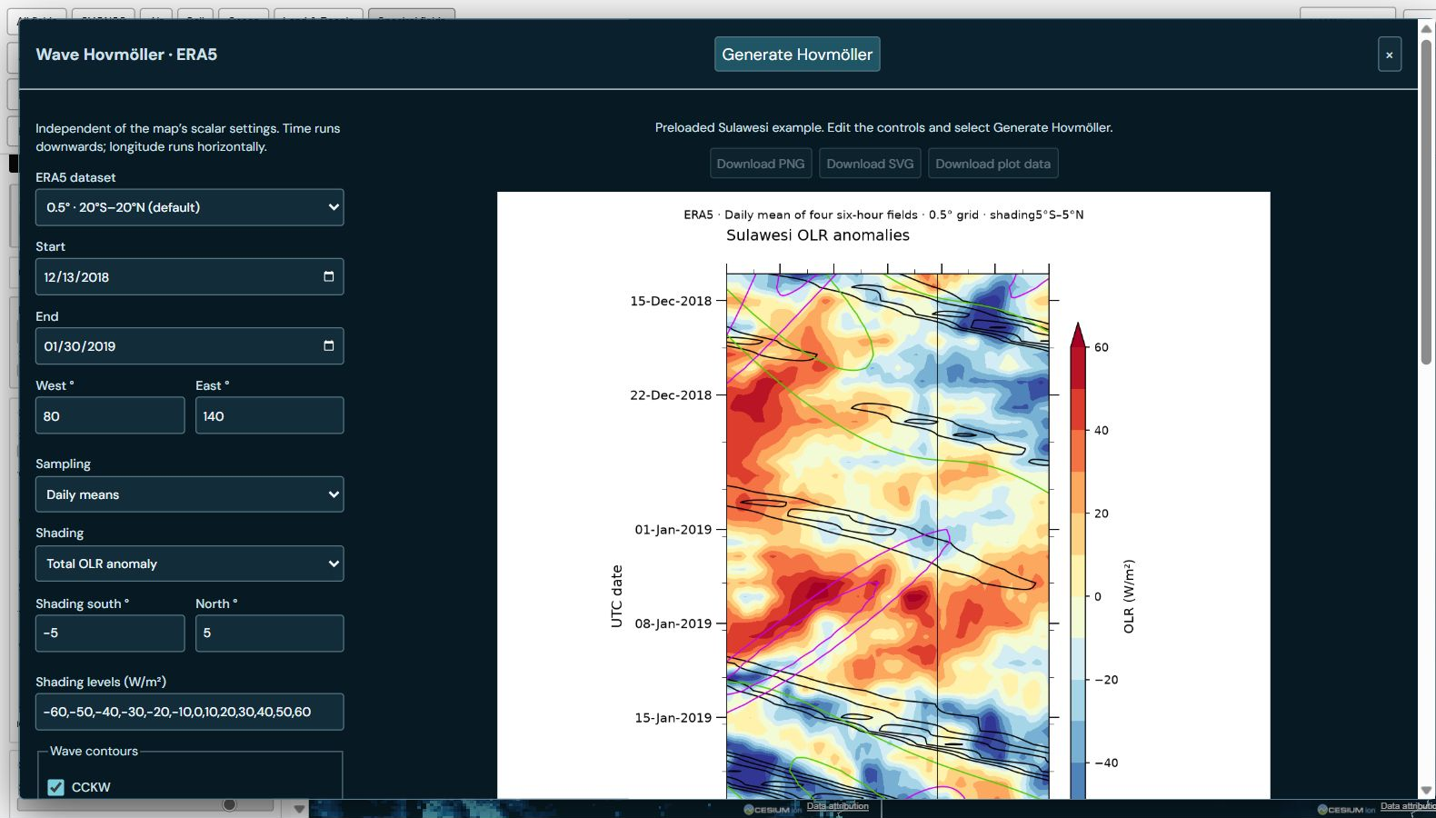
Figure 11. Use the independent Wave Hovmöller.
The default Sulawesi illustration covers 13 December 2018–30 January 2019 and 80–140°E. Shading averages 5°S–5°N; CCKW contours use 10°S–5°N, MJO 15°S–15°N and ER 20°S–5°S. The screenshot shows the preloaded example. Select Generate Hovmöller to apply edited controls; changing controls alone does not regenerate it.
Optional trajectories have independent selections and a minimum amplitude. After generation, Download PNG, Download SVG and Download plot data save the image, vector figure and numerical/settings JSON. Preserve the data and renderer for reproduction. Map PNG and workspace JSON serve different purposes.

12 Save and transfer settings
Save JSON exports the layer workspace; Load JSON restores an exported workspace file. Use these header buttons to transfer the current workspace between browsers or keep a reproducible settings snapshot. They save settings, not copies of the source datasets.
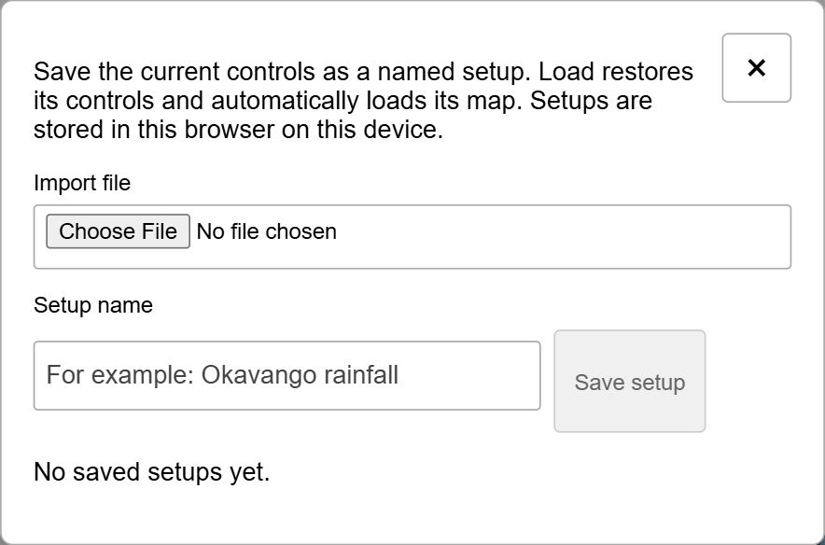
Figure 12. Save and transfer settings.
Saved setups provides named browser-local cases and import/export of setup files. Enter a name and Save setup; Load restores an entry. A saved entry’s Save replaces it, File exports it and Delete removes it. The screenshot shows Saved setups.
Browser storage is tied to the current site, browser profile and device. Keep an exported file if you need to transfer or retain a study. The plot tools have their own data exports; a named setup or workspace JSON is not a substitute for the calculated plot data.

13 Export a map figure
Save PNG and Print / PDF in the header export the current map composition. Export options opens the resolution and caption controls. Choose Screen size or High resolution at 3200 pixels per map. Include caption, field ranges and credits preserves the information needed to interpret the figure.
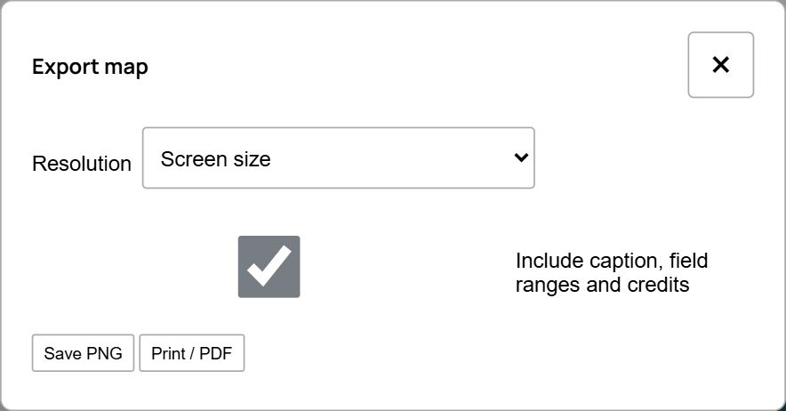
Figure 13. Export a map figure.
Check that the intended date and layers have finished loading before export. The exported view records visible layers, their colours, map position and available captions. It is a figure, not a numerical archive. Preserve the workspace JSON separately when you need to reconstruct settings.
For regional plots use their SVG and, where available, CSV exports. For Wave Hovmöller use its PNG, SVG and plot-data downloads. For trajectories use GeoJSON. These formats preserve different parts of the study and should be chosen for the intended reuse.

14 Reset the study and open documentation
The gear button opens Settings. All text, secondary guidance and documentation links are black on the white panel. English and Polish PDF and Word links are visible directly under Documentation. The release label matches the manual version. Both formats contain linked chapter contents; the PDF also provides bookmarks.
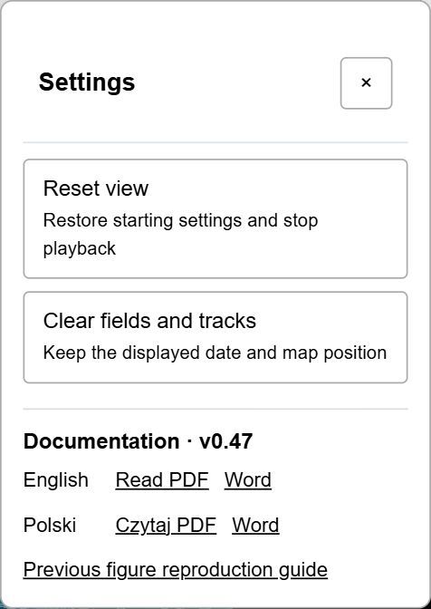
Figure continues below.
Figure 14. Reset the study and open documentation.
Reset view restores the starting study and stops playback. Clear fields and tracks removes the selected fields and trajectories while keeping the displayed date and map position. Both preserve Saved setups. Use the header’s Back and Forward to revisit workspace changes when available.
To share navigation, open a supported panel and copy the browser address. A panel link only opens that destination. To share edited settings, export JSON; to share a prepared example, copy its example address.

15 Complete interface reference
The following inventory covers the header, left-hand workspace, per-layer options and dialogs. Options appear only when supported by the selected layer. There is no Apply button in the main workspace; changes load automatically.

15 1 Header categories
All fields. Show the full searchable field catalogue. Changing category keeps selected layers.
CYGNSS. 1-day and 3-day water fractions and anomalies, Spatial and Temporal candidates.
Air. CHIRPS and IMERG rain, ERA5 atmospheric fields and wind-particle animation.
Soil. Soil moisture and temperature by depth, ERA5-Land near-surface fields, runoff, evaporation and snowmelt.
Ocean. Sea-surface temperature and surface-current speed.
Land & People. Vegetation, population, elevation, land-cover classes, historical water and reference reports.
Spectral fields. Total and filtered OLR, MJO/CCKW/ER trajectories and seasonal ITCZ axes.
Hover descriptions. Pause over category names, field labels or controls for their dataset or action description.

15 2 Header actions and time
SpectralWeather release. The visible release number matches the current English and Polish manual editions.
Back / Forward. Restore earlier or later workspace configurations in this session. Disabled at the ends of history. These are separate from browser navigation.
Save JSON / Load JSON. Export or import the selected layer workspace as a file. Load JSON opens a file picker. Source data are not embedded.
Save PNG / Print / PDF. Save a map composition or open the print dialog using Export options. Browser pop-ups may need permission.
Reset view. Restore the initial study and stop playback; keep saved cases.
Examples. Open prepared map and plot recipes. Back to controls exits example mode; Other examples returns to the list.
Hovmöller / Time series. Open regional plots using the first two eligible visible numerical layers; calculate with Plot.
Wave Hovmöller. Open independent longitude-time OLR diagnostics; calculate with Generate Hovmöller.
Saved setups. Open named browser-local cases, import and export.
Help. Open workspace guidance, Dataset Info, Help dates and manual links.
Export options / Preparation. Choose figure resolution/captions, or explicitly prepare cached responses for preceding playback dates.
Date / ERA5 interval. UTC end date and six-hour interval. Each layer may follow it, use an offset or hold a fixed date.
Now / Prev / Play / Next. Now selects archive latest. Prev/Next move one day or a labelled ERA5 six-hour step. Play changes to Pause while running. Loading and displayed-date messages show progress.
BAMNET site / Settings. Open BAMNET in a new tab, or open reset/clear and direct PDF/Word manuals. Close Settings with × or Escape.

15 3 Left hand workspace controls
1 map / 2 maps. Overlay all assigned fields on one map, or display two comparison panels.
Link map views. Synchronize cameras while moving either comparison map. Turn off for independent navigation.
Lat–lon grid / View. Toggle the coordinate grid; choose Globe or Lat–lon projection.
Add fields to Map 1 / Map 2. Destination for newly added layers. Existing assignments stay on their current maps.
Select fields / Find a field. Expand or collapse the catalogue; search field names within the selected category. The count includes all selected layers.
Field checkbox. Add or remove that named layer. Newly selected layers appear at the top of the stack.
Rain presets. 1-day rain is the selected date; Last 3/7 days is accumulated rainfall with its own trailing window.
Background / Opacity. Choose Boundaries, OpenStreetMap, Esri imagery, Terrain or Black. Its separate opacity adjusts the fixed bottom layer.
Layer name / arrows / ×. Read the variable and hover description, reorder up/down, or remove the layer. Top layers draw above lower ones.
Layer Opacity. Change visibility without changing data values. Zero hides the field; full opacity can hide layers below it.
Field settings / Track settings. Expand each layer’s applicable controls. The summary shows date range, level, window, calculation, map assignment and scale where relevant.
Loading / errors / selected count. Read per-layer errors and the bottom status. Wait for loading to finish before exporting. Scroll this column to reach lower cards.
earth + / earth −. Show or hide the controls, leaving the map visible.

15 4 Field settings in detail
Map 1 / Map 2 / Both. In two-map mode, assign this existing field to either map or both.
Level. Where available choose Surface, 850 hPa or 500 hPa. Level applies to this scalar or wind-animation layer.
Follow / Fixed / Days before. Follow the header, hold a chosen date, or offset the effective date by up to 90 days. Read the resulting date in the summary.
Window. 1, 3, 7, 14, 30 days or custom 1–90 days, including the effective end date. Static references do not use this control.
Rain / Calculate. Rain presets select daily rate or 3-/7-day total. Calculate selects mean/min/max and sum where supported.
Values. Obs shows observations. Abs, Rel and Std select supported absolute, relative or standardized anomalies. Options depend on the dataset.
Colours / Contours. Choose filled colours or equal-value lines. Interval sets contour spacing; Use visible region resamples contours after moving the map.
Hide inundation below / Hide light rain. Make low map values transparent without removing measurements from numerical plots. Set the adjacent fraction or rainfall threshold.
Scale Reset / Auto. Restore default limits or fit valid values in the visible region of the assigned map.
Symmetric / Hide near zero. For anomaly fields, keep equal-magnitude limits around zero or hide values near zero using the adjacent threshold.
Minimum / maximum and two sliders. Set the same lower/upper colour limits numerically or with the two handles. Units change for rain totals. Class fields show a class legend instead.
Source & coverage. Expand provenance, dataset meaning and coverage/temporal notes returned for this layer.

15 5 Track settings in detail
Map / Date. Map assignment, Follow/Fixed and Days before work as for other changing layers.
Source. ERA5 0.5°, NOAA daily or retained ERA5 0.25°. NOAA is available for MJO/CCKW; ER requires ERA5.
Trail. Positions or 7, 14, 30, 60 preceding days. These are candidate paths, not future predictions.
Minimum OLR. Filter candidates by selected-date peak negative filtered OLR amplitude, 0–100 W/m². Does not rerun detection.
Lat–lon extent. Show the selected-date detected patch bounds. These boxes do not express uncertainty or future extent.
GeoJSON / Source & coverage. Download displayed geometry or expand source and limitations. Seasonal ITCZ is a separate climatological layer.

15 6 Map interactions and dialogs
Map drag / wheel / legend. Drag to navigate, wheel to zoom; read the legend’s date, variable, units, limits and opacity. In two-map mode activate a map by clicking it.
Map point. Click a location for coordinates and choices for Hovmöller, Time series or Upstream catchment. × closes the point card.
Candidate / report markers. Click a candidate for observed date, cells, anchor and accepted links. Report markers open source records; Read article opens the newspaper.
Catchment card. Shows selected point, joined drainage-unit count and area. Fit catchment frames it; Remove catchment removes it; × hides its information card.
Regional plot controls. West/South/East/North, Use map region and Draw region on map define a rectangle. From/Through, Average and Step define time sampling. Show selects Field1/Field2; Direction selects time-series or Hovmöller axes.
Regional plot scale and exports. Set each input’s limits or Fit plotted values. Plot recalculates; Cancel stops; Download SVG exports a figure, CSV exports time-series values. Additional Hovmöller controls select shading/contours and interval. × closes.
Wave Hovmöller controls. ERA5 dataset, dates, longitude, Sampling, Shading, latitude bounds, shading Levels; independent CCKW/MJO/ER contour switches/bands/levels; optional trajectories/waves/threshold; aspect ratio; reference longitude/date.
Wave generation and export. Generate Hovmöller runs the calculation; Cancel stops it. Status and error text report progress. Methods and export explains the algorithm and offers the Python renderer. PNG/SVG/plot-data downloads enable after the appropriate calculation stage.
Preparation / Export options. Playback days, Prepare selected fields, Stop preparation, Clear prepared responses and cache status; export Resolution, Include caption, Save PNG and Print / PDF.
Saved setups / Settings / Help. Import file, Setup name, Save setup; entry Load/Save/File/Delete. Settings offers Reset view, Clear fields and tracks, release-matched PDF/Word manuals and the reproduction guide. Help links Dataset Info and Help dates.
Messages and close controls. Loading, unavailable-data, preparation and export messages explain pending or failed work. Dismiss × hides a notice. Dialog × or its close control returns to the map; Escape closes Settings.

16 Scientific interpretation and wave figures
CYGNSS inundation is a surface-water fraction, not water depth or a confirmed flood boundary. A fraction of 0.05 is 5%. Its spatial coverage is approximately 38°S–38°N; absent colour may indicate missing data or a display threshold. Compare observations, anomalies and report evidence separately.
A 3-day CYGNSS product, a multi-day calculation window and a trajectory trail measure different things. Do not infer a lag, causal relationship or event match from colour blending or coincident markers alone. For fixed references such as population, land cover and historical water, the header date does not imply a new observation.
The four wave figures illustrate the Sulawesi study using total OLR anomalies and CCKW, ER and MJO filtered OLR. Wave Hovmöller calculates the latitude means and draws shading and independently configured contours with Matplotlib and NCAR GeoCAT. Compare the field, averaging band and contour levels before interpreting each pattern.

Total OLR anomaly
13 December 2018–30 January 2019; 80–140°E; daily means; shading 5°S–5°N. Units W/m². Black contours: CCKW 10°S–5°N; green: MJO 15°S–15°N; magenta: ER 20°S–5°S. Reference: 119.2°E and 23 January 2019.
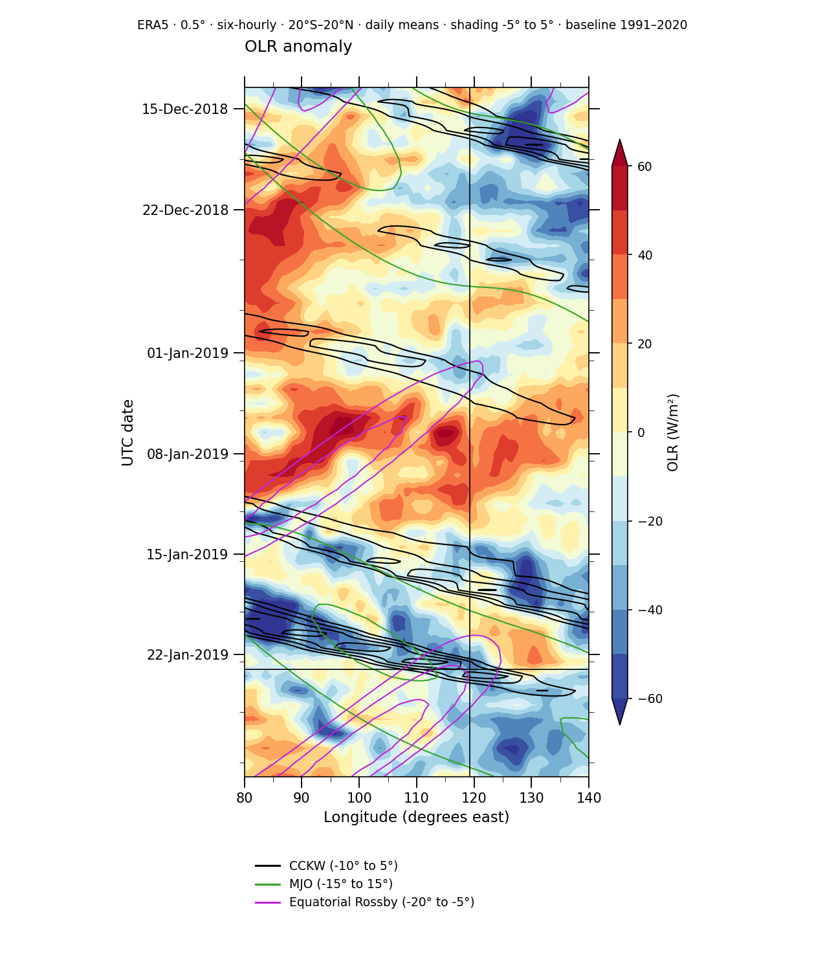
Generated with Wave Hovmöller. Total OLR anomaly.

CCKW filtered OLR
13 December 2018–30 January 2019; 80–140°E; daily means; shading 5°S–5°N. Units W/m². Black contours: CCKW 10°S–5°N; green: MJO 15°S–15°N; magenta: ER 20°S–5°S. Reference: 119.2°E and 23 January 2019.
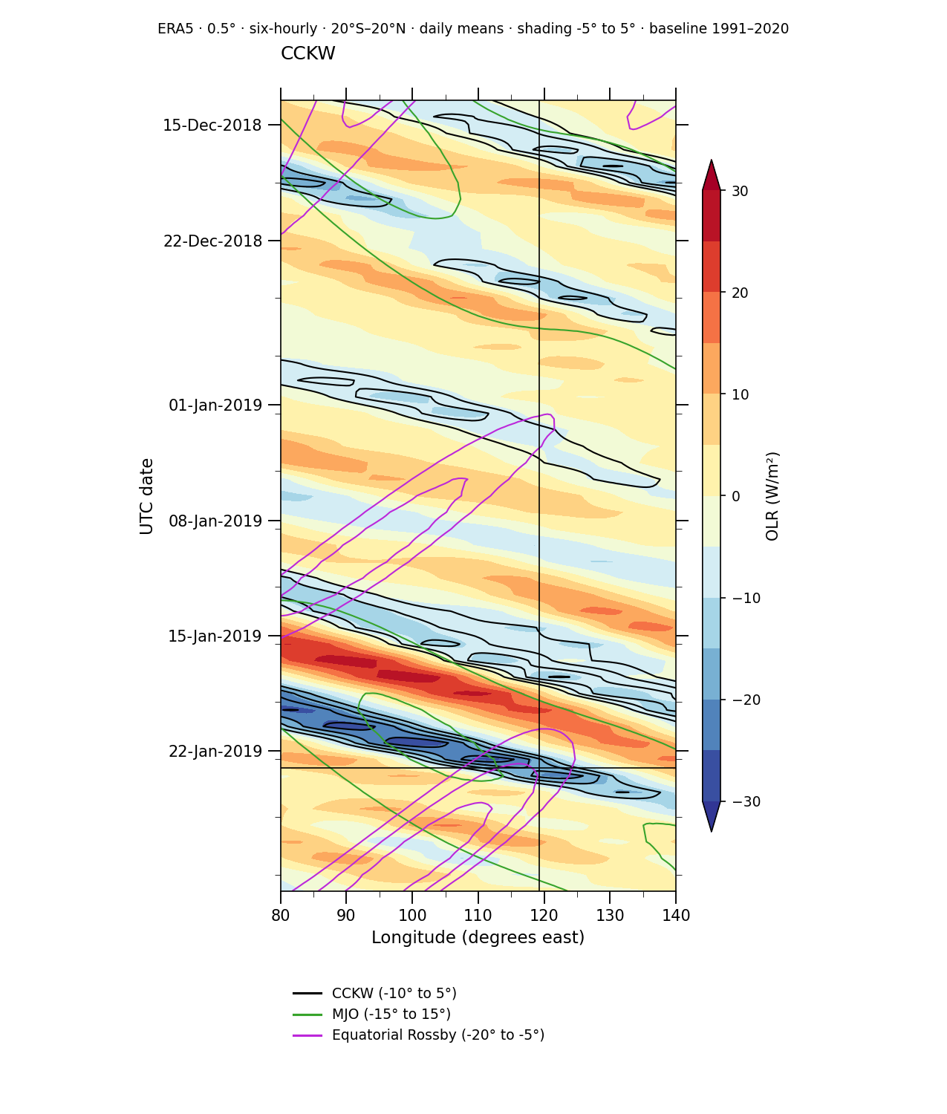
Generated with Wave Hovmöller. CCKW filtered OLR.

ER filtered OLR
13 December 2018–30 January 2019; 80–140°E; daily means; shading 5°S–5°N. Units W/m². Black contours: CCKW 10°S–5°N; green: MJO 15°S–15°N; magenta: ER 20°S–5°S. Reference: 119.2°E and 23 January 2019.
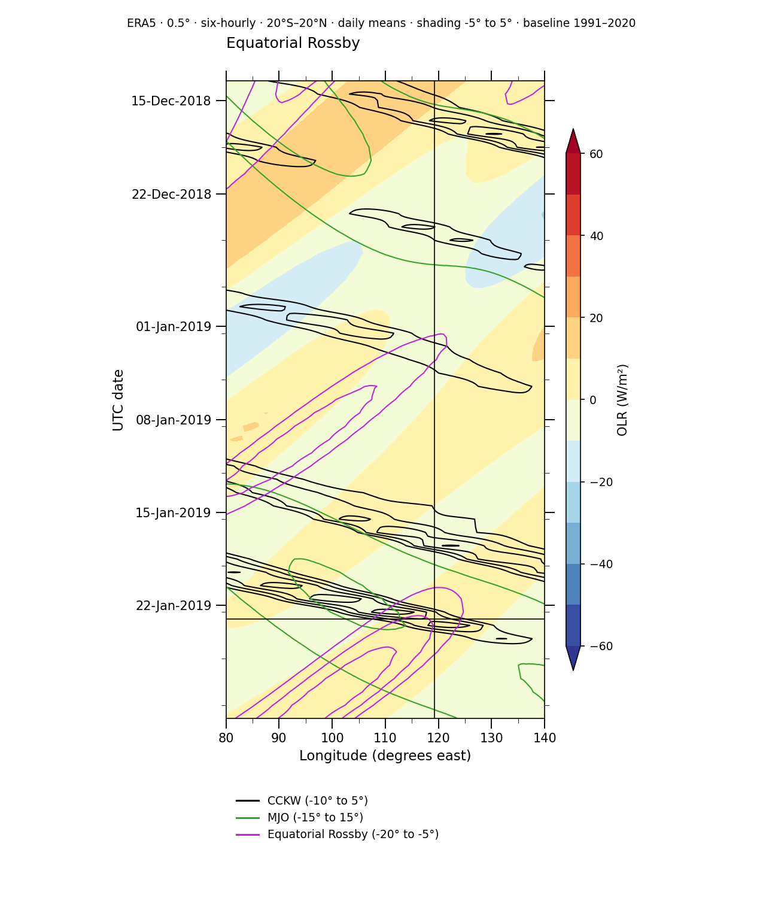
Generated with Wave Hovmöller. ER filtered OLR.

MJO filtered OLR
13 December 2018–30 January 2019; 80–140°E; daily means; shading 5°S–5°N. Units W/m². Black contours: CCKW 10°S–5°N; green: MJO 15°S–15°N; magenta: ER 20°S–5°S. Reference: 119.2°E and 23 January 2019.
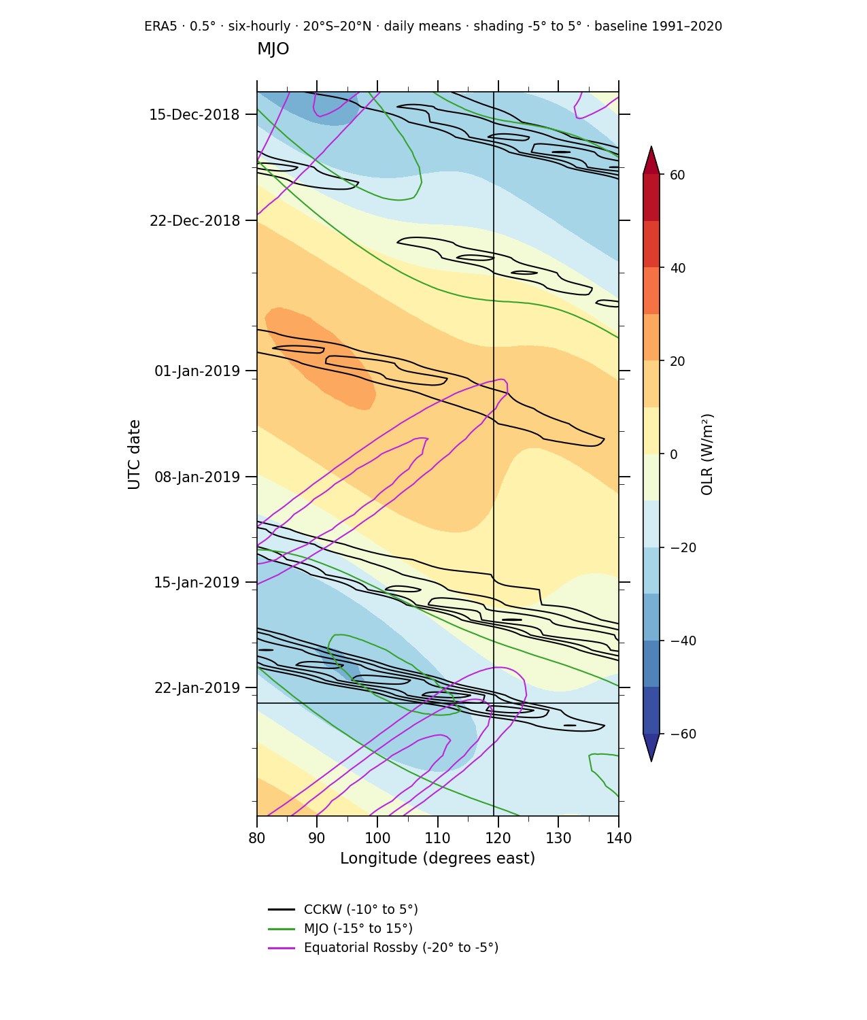
Generated with Wave Hovmöller. MJO filtered OLR.

17 Scientific figure recipes
The figure guide provides settings for maps, time series, wave fields and trajectories. Choose a recipe, load its dates and region, then calculate the plot. Save the workspace JSON for map settings and the plot-data JSON for Wave Hovmöller. Keep the source, averaging bands and numerical exports with any figure you share.
Scientific figure guide
The following recipes start with a question and show how to read the result. The diagrams explain the ideas; they are not interface screenshots or additional observations. You do not need to understand the mathematics in chapter 20 to follow these steps.

17.1 Compare two maps fairly
Question: is more surface water visible where there was more rain? Choose 2 maps and switch on Link map views so both maps show the same place. Put CYGNSS on Map 1 and rainfall on Map 2. Start with the same end date and a 1-day window on both layers.
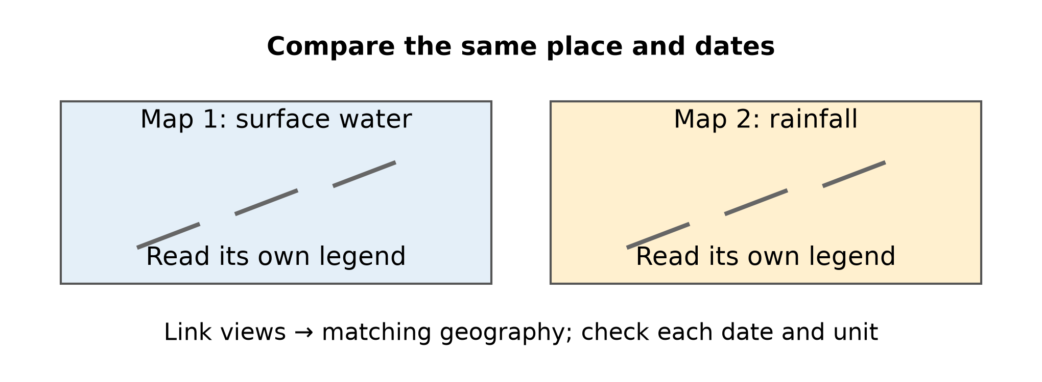
Figure 17.1. Two panels keep the geography aligned while leaving each variable’s scale readable.
Read each legend separately. A water fraction of 0.05 means that water covers an estimated 5% of a cell; 5 mm of rain means a water depth of 5 mm spread over the ground. These numbers measure different things. Two maps are usually easier to read than two partly transparent colour layers on one map.

17.2 Look for rain before the water response
Question: did rainfall precede the increase in surface water? Open the Okawango Northern rain + catchment example. It compares a water window of 25–31 January 2022 with rain on 24–30 January. Both windows contain seven days, but the rain window ends one day earlier.
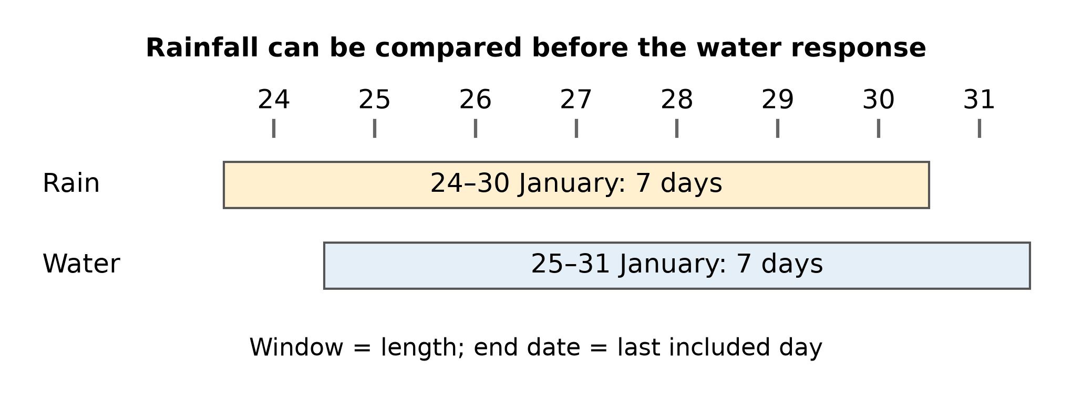
Figure 17.2. The highlighted intervals show which days enter each calculation. They are date windows, not measured rainfall bars.
Window means how many days are included, counting backwards from the layer’s end date. Days before shifts that end date. Changing transparency cannot shift a date. Start with a short delay, then compare several delays: rain may take time to reach a river or floodplain. An apparent match alone does not prove that the rain caused the water increase.

17.3 Follow one region through time
Question: when did the region become wetter? Open Examples → Okawango → Time series, then choose Plot. The recipe uses the rectangle 22.2–23.8°E and 19.95–18.35°S during 2022, with 30-day means and a 30-day step. A time series is a sequence of values for the same region on successive dates.
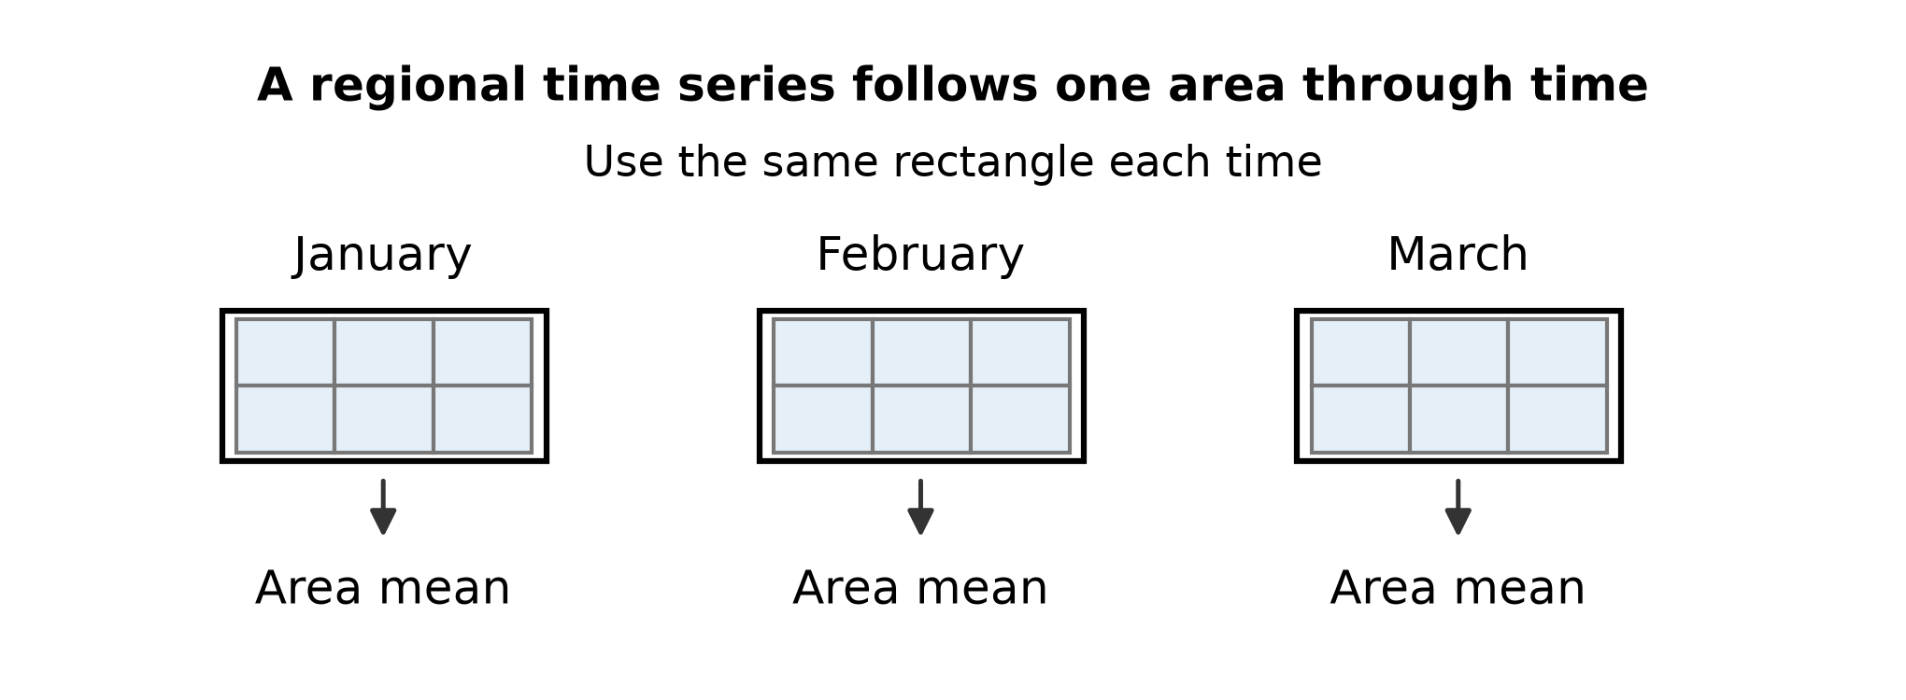
Figure 17.3. The same outlined region is summarized repeatedly; the grid is an explanatory sketch, not observed data.
Keep the rectangle fixed while comparing dates. The regional mean summarizes valid sampled pixels; a blank pixel is not treated as zero. Window smooths a period, while Step controls how often a result is drawn. For rainfall and water on one chart, read their separate axes and units. A regional average can hide a strong local event.

17.4 Read a wave diagram one ingredient at a time
Question: how did a large area of tropical cloudiness move? Open Wave Hovmöller and use the Sulawesi dates, 13 December 2018–30 January 2019, and 80–140°E. Longitude runs left to right and dates run down the page. First inspect the coloured shading. Then add one family of contour lines at a time.
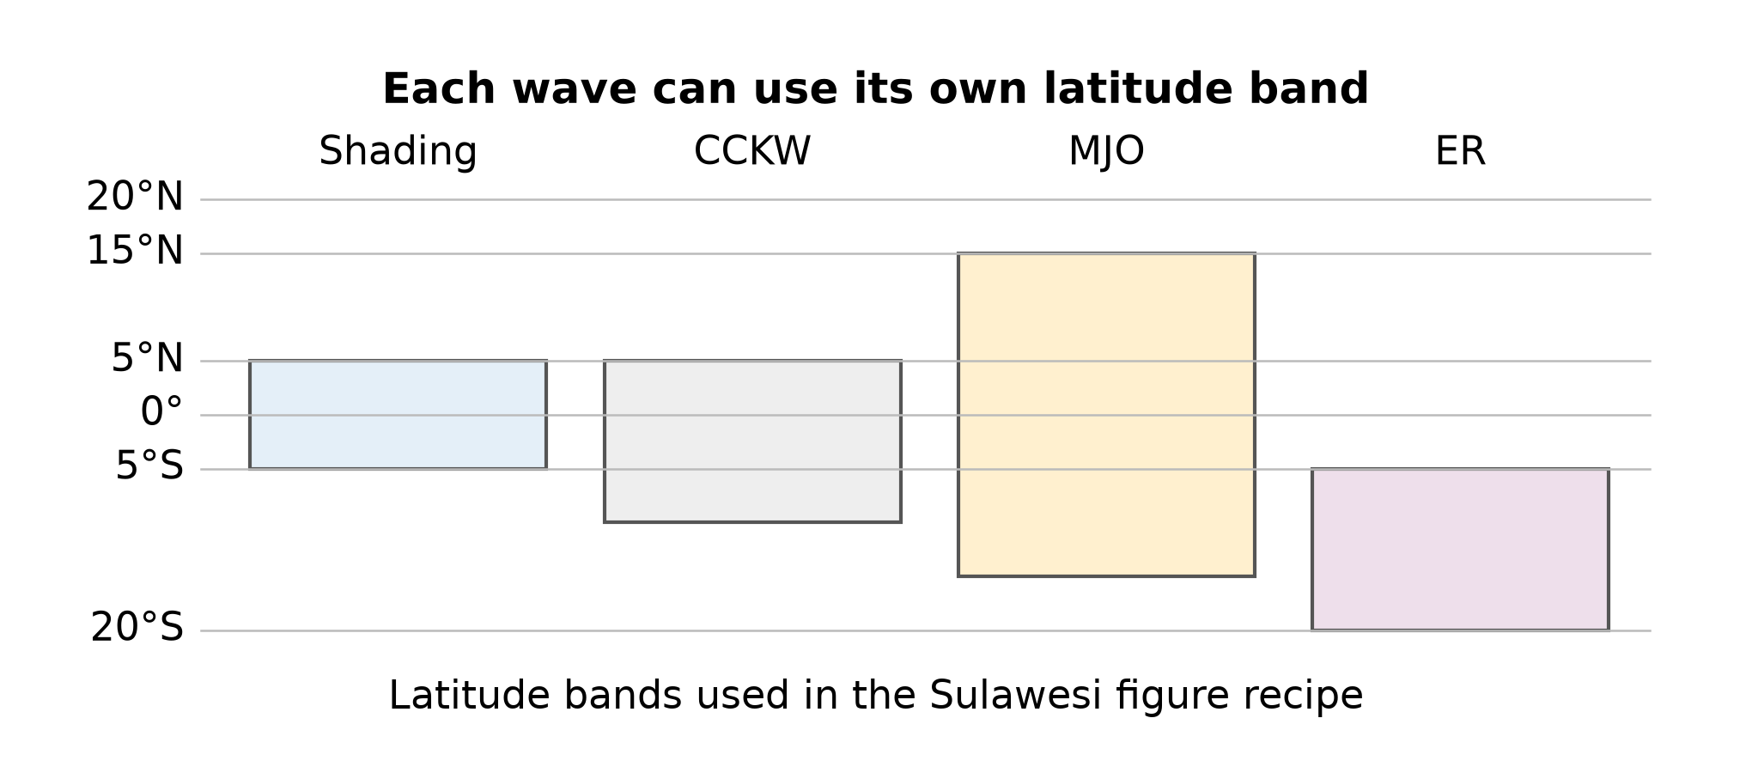
Figure 17.4. These are the Sulawesi recipe’s averaging strips, not universal latitude limits for the waves.
A latitude band is the north–south strip averaged to produce the diagram. The Sulawesi recipe uses different strips for shading, CCKW, MJO and ER, as shown below. Therefore a contour and a coloured patch need not describe exactly the same region. Negative filtered OLR suggests more deep cloud activity in that wave band; it is not a direct measurement of rain or moisture. Select Generate Hovmöller after changing the settings. Chapter 16 shows the resulting scientific figures.

17.5 Distinguish a position a path and an extent
Question: where was the detected cloud pattern, and where had it been? Add a trajectory layer under Spectral fields. For the Indonesia recipe choose ERA5 0.5°, 23 January 2019, 12–18 UTC, and a 14-day trail. A dot marks a detected position, while the trail joins earlier detections.
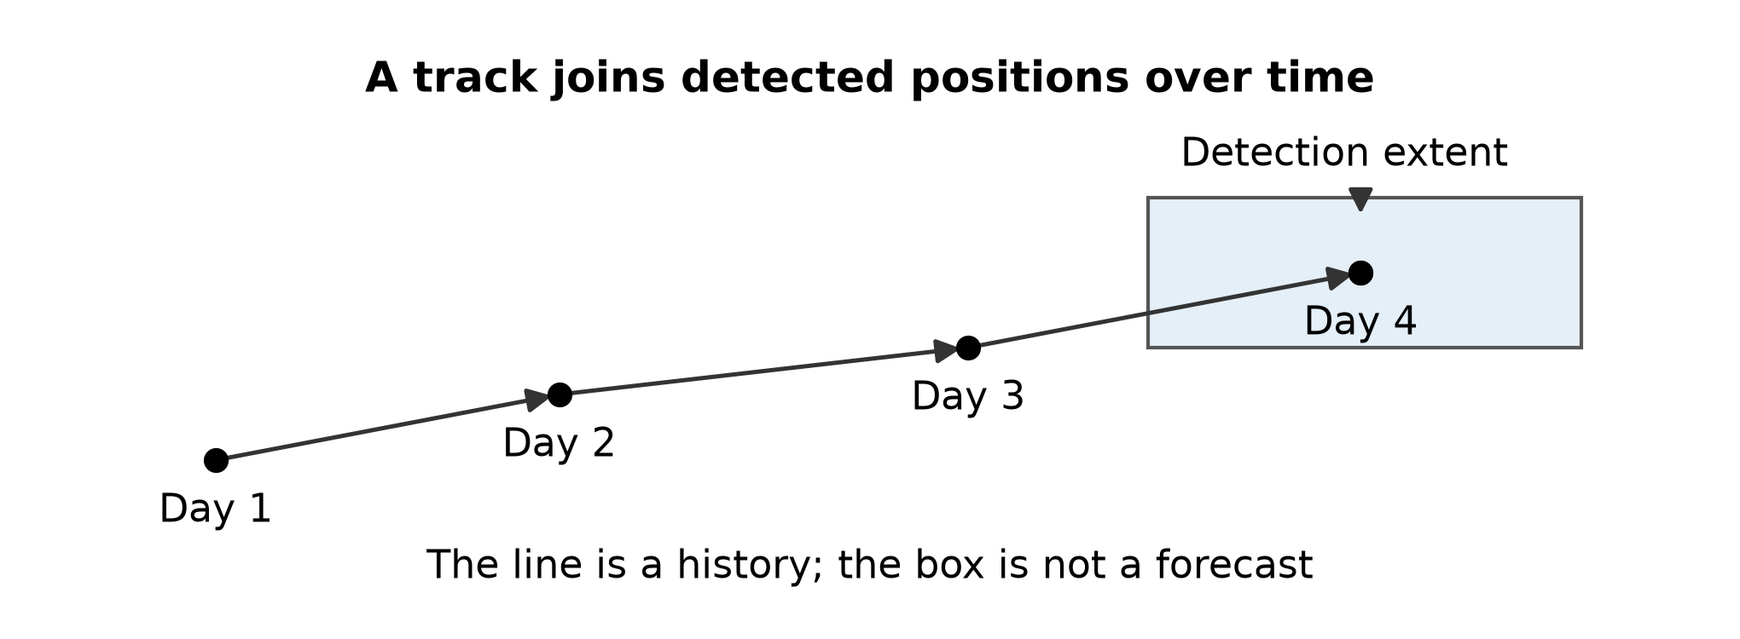
Figure 17.5. Schematic positions and extent explain the symbols; the drawing is not an observed wave track.
Switch on Lat–lon extent to see the rectangular limits of the detected patch. The rectangle is not a forecast cone or an error bar. The line follows a cloud-pattern detection, not a parcel of air or the course of a river. Increasing the displayed minimum amplitude hides weaker detections; it does not run the tracking method again.

17.6 Save enough information to repeat the study
Question: could somebody else recreate this figure? Save the image, the calculation settings and the numerical results where the tool offers them. For a map use Save PNG and the header Save JSON. For Wave Hovmöller use Download PNG or SVG together with Download plot data. Regional plots offer their own exports.
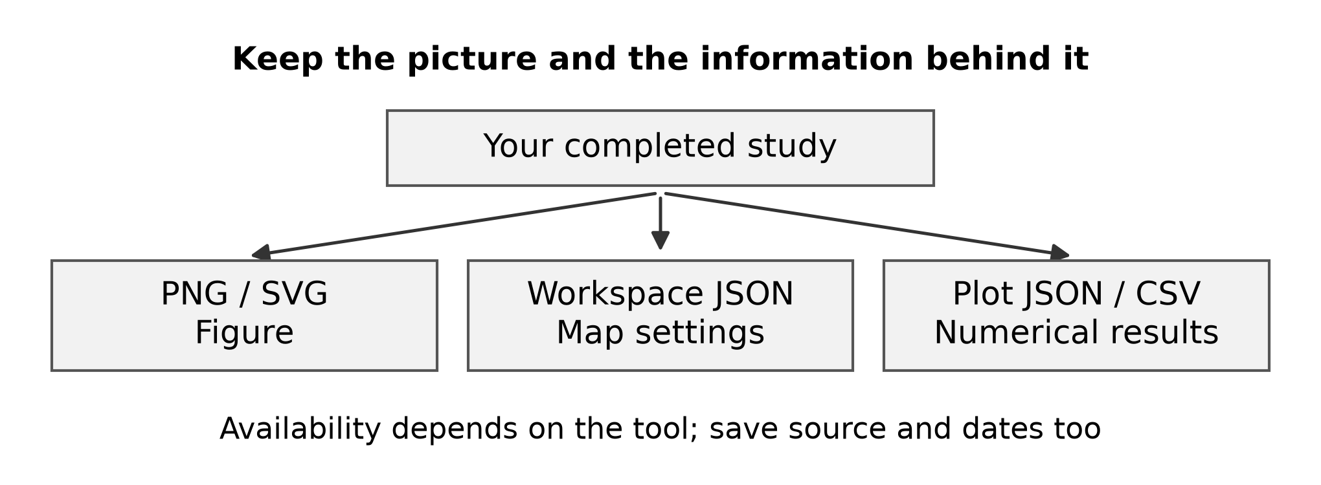
Figure 17.6. A figure communicates the result; settings and numbers make the calculation inspectable.
PNG is an image; SVG keeps lines and text sharp when enlarged. Workspace JSON records map settings, while plot-data JSON records the wave plot’s settings and values. They serve different purposes. Record the source, dates, region, averaging bands and units in the caption. For a large printed map, choose High resolution in Export options.

18 Sources
Use layer descriptions and Source & coverage in the app for dataset provenance. Use the archive manifests for filtering and tracking methods. Interface behavior in this manual was checked against the application source and captured controls.
ERA5 0.5° archive metadata
NOAA OLR archive metadata

19 Software and architecture

Browser workspace
The interface uses React and TypeScript, with a Next.js application structure built by vinext and Vite. CesiumJS displays the globe and map layers. The browser manages layer selection, map assignments, date controls, colours, opacity, legends and animation.
The main workspace loads changed settings automatically. Browser memory holds prepared responses within size, count and time limits; it is not a permanent data archive. Saved setups uses site storage in the browser, while Save JSON exports settings for transfer. Source data are not embedded in a workspace JSON file.

Cloud services and data paths
The service runs on Sites hosting with a Cloudflare Worker backend. For Earth Engine products, the browser sends a request to /api/earth-engine. The backend calls the Google Earth Engine REST API for image selection, time aggregation, statistics, anomalies and spatial means. The browser receives map-tile information or numerical results. Earth Engine credentials remain on the server.
Spectral fields follow a separate archive path. The 0.5° and retained 0.25° ERA5 archives have public metadata and compressed monthly field chunks served from R2 storage through /api/spectral-half and /api/spectral. The browser decodes requested chunks and calculates display windows and latitude averages. The full-record wave filtering was performed in advance; changing a contour level does not rerun that filtering.
Spatial and Temporal CYGNSS candidates are read from monthly catalogues and filtered for display in the browser. Wave trajectories use their own detection catalogues. These catalogue layers do not submit candidate-detection jobs to Earth Engine. Basemap imagery and tiles are another independent source.
Upstream catchment uses Earth Engine and HydroBASINS level-6 drainage units. It joins the unit containing the selected point with its upstream units. The selected point is not snapped to a river outlet. This is a static drainage approximation, not a CYGNSS flood boundary, and it does not automatically become the mask for regional plots.

Plotting and requirements
Map contours use JavaScript CONREC. Regional Hovmöller and time-series tools produce browser SVG graphics. The independent Wave Hovmöller uses a Web Worker with Pyodide, a WebAssembly Python runtime, to run Matplotlib and NCAR GeoCAT. Its first calculation downloads plotting packages; the worker keeps that calculation separate from the map interface. PNG, SVG and plot-data JSON exports preserve different parts of the result.
An internet connection and a browser supporting WebGL are required. No separate local Python installation is needed to use the website. Large date ranges, multiple maps and the Python plotting runtime consume additional memory; available device resources affect performance. Download the renderer and plot-data JSON if you want to reproduce a Wave Hovmöller outside the browser.

20 Data and scientific methods
This chapter follows the calculation from source data to a displayed field or candidate track. Source measurements, derived diagnostics and display settings have different meanings. Preserve the source, dates, calculation window, baseline and export data when sharing an analysis.

20 1 Earth Engine and the community catalogue
Google Earth Engine (GEE) stores geospatial collections and executes calculations on its servers. SpectralWeather sends a structured request to its own /api/earth-engine endpoint; the backend authenticates with OAuth 2.0, refreshes an access token and submits an expression to the Earth Engine REST API under the configured Cloud project. Map requests return tile information, while value requests return numbers or sampled arrays. The application does not send its OAuth refresh credentials to the browser. Visitors do not need to authenticate to Earth Engine themselves to use these configured layers.
The Awesome GEE Community Catalog is a community-maintained collection of dataset descriptions, citations and public Earth Engine asset references. It complements the Google catalogue. The CYGNSS entry points to projects/sat-io/open-datasets/CYGNSS/inundation. Credit the original data producers and the catalogue; an asset being available through GEE does not make it a Google-produced measurement.
Temporal and Spatial candidates, archived spectral fields and wave tracks have separate precomputed file paths. Loading these catalogues does not launch a new flood detector or spectral transform in GEE. Data availability, masks, quotas and pressure-level gaps still constrain Earth Engine layers; an empty result is not a measured zero.

20 2 CYGNSS fractional inundation
CYGNSS receives reflected GPS signals. The inundation product converts surface reflectivity to the fraction of a grid cell covered by water, using a soil–water mixing model and ancillary soil-moisture, roughness and vegetation information. A fraction of 0.20 means 20% water coverage within a cell; it does not mean 20 cm depth. Water already present in a lake or wetland is not automatically a flood.
The 1-day band contains observed cells. The 3-day product combines a longer sampling window with spatial interpolation; it is a different product, not three independent daily observations. The candidate detector uses the 1-day inundation and 1-day anomaly bands together. Native packed inundation is divided by 100. Packed anomaly has a +100 offset: (packed anomaly − 100)/100 gives the fractional anomaly. Fill value 255 is missing. The source climatology defines the CYGNSS anomaly; it is not the ERA5 1991–2020 OLR baseline.

20 3 Spatial flood candidates
In plain language, Spatial means nearby on the same day. First find cells with enough water and a large enough increase above usual conditions. Then look for a group of at least three cells joined along their sides. For example, 25% water compared with a usual 10% gives an increase of 15 percentage points, so both water tests pass. The packed values below are storage codes; you do not need to enter them in the interface.
For each available day, retain cells with valid inundation and anomaly. Require water fraction ≥0.20 and anomaly ≥0.10, meaning at least 10 percentage points above the source baseline. In packed values these are f ≥20 and a ≥110, with valid ranges f ≤100 and a ≤200. Both conditions must hold in the same cell and on the same date.
Join qualifying cells by shared edges: north, south, east or west neighbours. Diagonal contact alone does not connect cells. Keep components of at least three cells on the approximately 3 km equal-area EPSG:6933 grid. This is roughly 27 km² of candidate grid footprint, not 27 km² of fully inundated land. The map marker is the centre of the lowest-index anchor cell of a patch; it is not its centroid or outline.
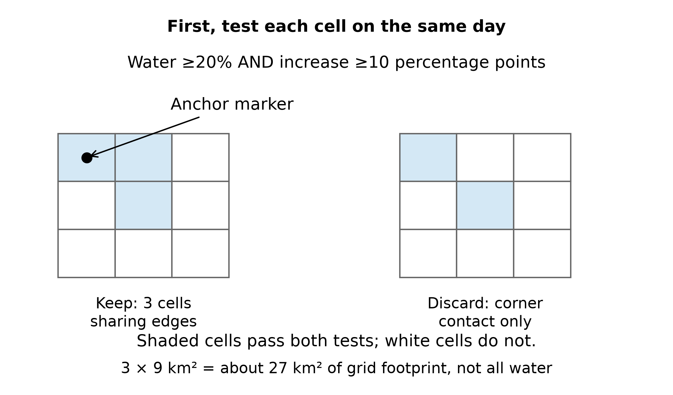
Figure 20.3. Schematic selection of neighbouring cells. The dot marks an anchor cell, not the centre of the whole group. Coloured cell area is the candidate grid footprint; only part of each cell may be water.

20 4 Temporal links and event components
Temporal means connected through time. Ask whether a qualifying patch reappears in the same grid cells within a week. A missing observation leaves the question open; an observed failure of the water test breaks that proposed connection.
Consider pairs of daily Spatial patches separated by 1–7 calendar days. Require at least one identical grid cell in their overlap. Reject that patch pair if any overlap cell has an intervening valid observation that fails either water or anomaly threshold. Missing intervening observations do not constitute negative evidence. The rule uses observed overlap, rather than distance between map markers.
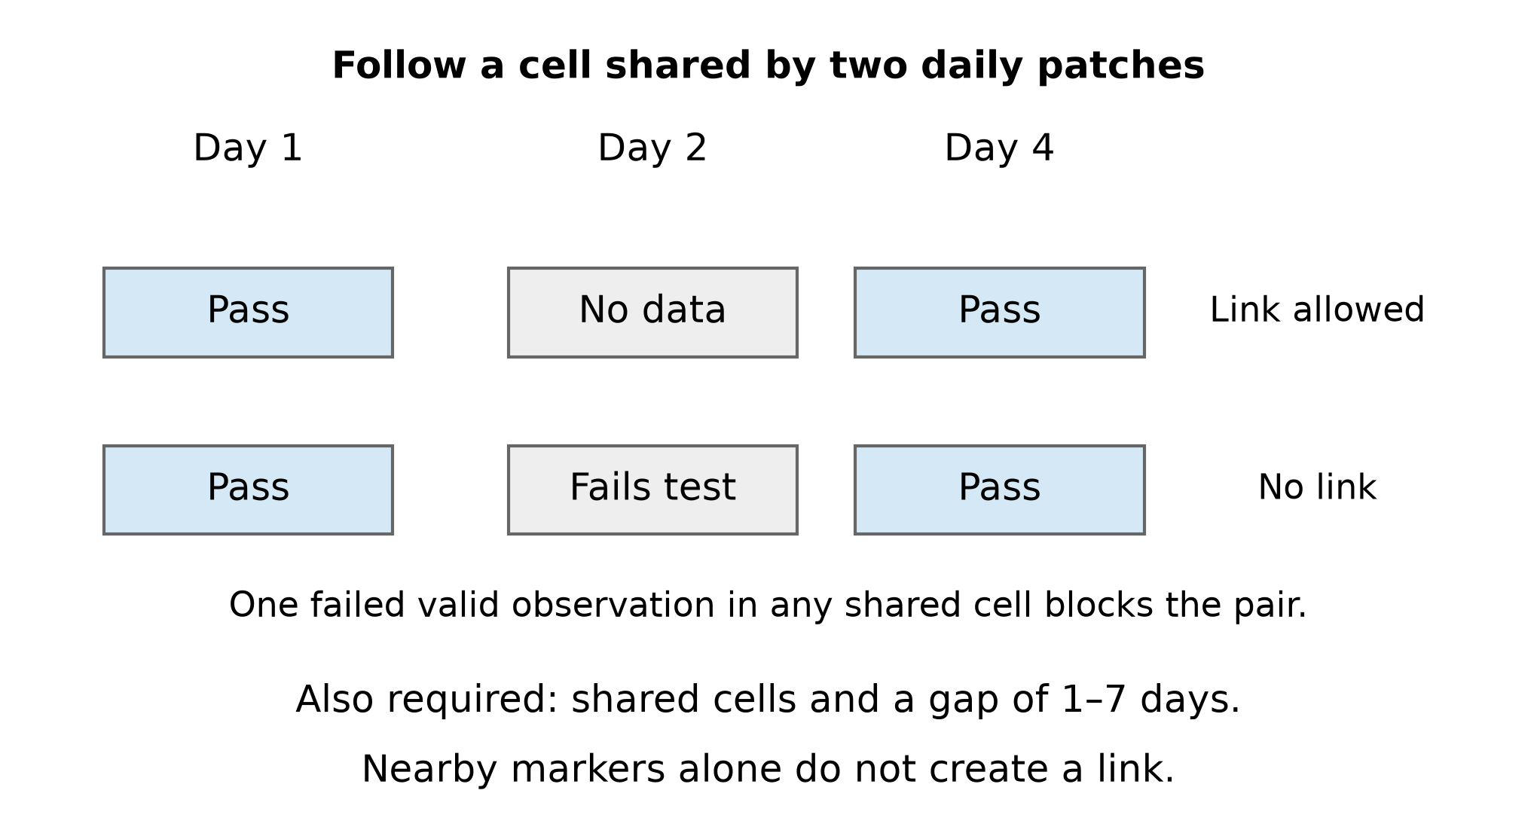
Figure 20.4a. Schematic checks for a shared cell. Missing data do not cancel a possible link, but an intervening valid observation that fails either threshold rejects the patch pair. All shared cells must be checked, and the end dates must be 1–7 days apart.
A Temporal marker is a daily patch with at least one accepted link. It may link to a date outside the displayed map window. A connected component of the link graph can contain several patches per day, splits, mergers and long persistence. Counting daily markers measures patch activity; counting graph components measures linked episodes. Neither is an independently validated number of flood disasters, and the first observed patch is not necessarily the physical onset.
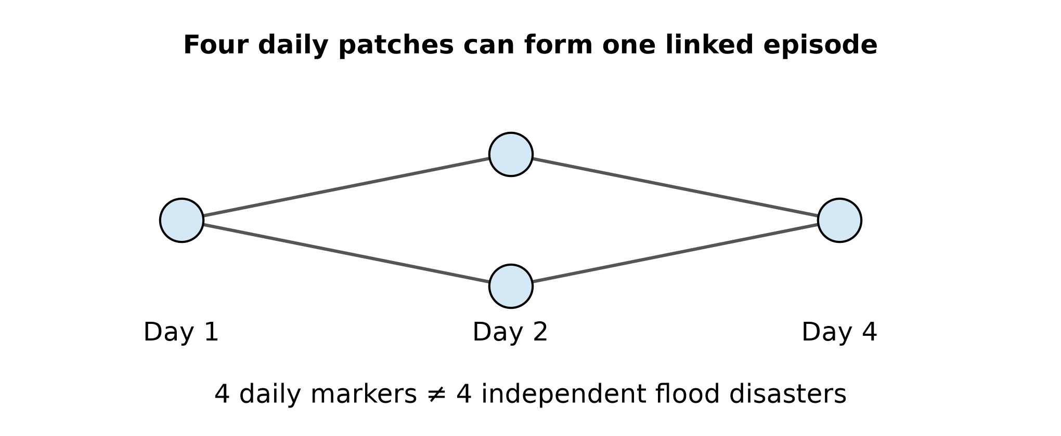
Figure 20.4b. Each circle is a daily patch; lines are accepted links. All four circles belong to one connected episode even though the pattern splits and merges. Neither count is a number of confirmed flood disasters.
The local archive spans 1 August 2018–31 December 2025 with four missing source dates: 31 December 2020, 25 August 2024, 28 October 2024 and 31 December 2024. CYGNSS sampling varies geographically and through time, including reduced equatorial coverage. Compare candidates against valid observation opportunities, not missing cells treated as dry days. A temporal-link rule also favours repeated observations. Product calibration, soil moisture, vegetation and roughness can affect detection.

20 5 ERA5 and radiation inputs
ERA5 is ECMWF reanalysis: a weather model constrained by assimilated observations to estimate a consistent atmospheric history. It supplies hourly fields on atmospheric and surface levels. Its native atmospheric resolution is approximately 31 km; a 0.25° or 0.5° output grid does not create finer physical detail. ERA5-Land is a separate land reanalysis product. Reanalysis wind, rainfall and radiation are estimates, not direct measurements at a clicked point.
The spectral archive uses ERA5 mean_top_net_long_wave_radiation_flux with sign reversed to make outgoing longwave radiation (OLR) positive in W/m². Native quarter-degree cells are area-aggregated to 0.5°, not merely relabelled. Six-hour means use hourly validity times 01–06, 07–12, 13–18 and 19–24 UTC, with midpoints 03, 09, 15 and 21 UTC. Fields cover 20°S–20°N and all longitudes for 2018–2025; the 0.25° option covers 5°S–5°N.

20 6 Seasonal anomalies and spectral filtering
The OLR baseline uses all 360 monthly means in 1991–2020 from ECMWF CDS. Accumulated monthly thermal radiation is converted to mean outgoing flux using −value/86400. At each grid point, a duration-weighted least-squares fit estimates a constant plus three annual sine/cosine harmonics. Evaluation uses fractional calendar years, including leap years. Subtracting this climatology gives a seasonal OLR anomaly; it does not remove the diurnal cycle explicitly.
For each latitude separately, remove a linear trend from the anomaly, apply a 10% Tukey taper in time, and take a two-dimensional Fourier transform along time and longitude. The processing record runs January 2017–August 2026 so that the 2018–2025 target interval lies outside the tapered ends. Retain the wave-specific frequency and zonal-wavenumber mask, preserve its conjugate partner, and invert the transform to a real field. The masks use the Wheeler–Kiladis spectral approach with the application parameters below.
Wave | Period days | Zonal wavenumber | Equivalent depth m
CCKW | 2.5–17 | 1–14 eastward | 5–90
MJO | 20–100 | 0–9 eastward | —
ER | 9.7–48 | −10 to −1 westward | 5–90
Equivalent depth bounds select the Kelvin and n=1 equatorial Rossby dispersion curves; they are not water depths. Wavenumber sign denotes propagation direction. Filtering preserves latitude structure without a complete dynamical meridional-mode projection or symmetry decomposition. A filtered MJO field is not the multivariate RMM phase index. Negative filtered OLR indicates enhanced deep-convection tendency; it is not a direct measurement of moisture or flood probability.
Three masked ERA5 intervals, 1 May 2022, 1 August 2022 and 1 February 2024 at 00–06 UTC, use genuine ECMWF CDS hourly thermal-radiation repairs with the same averaging and regridding. These are not time-interpolated values. Browser fields are quantized to 0.5 W/m²; filtered display values are clipped at ±63.5 W/m², while total OLR is not clipped. Full-precision arrays drive filtering and tracking. Use the archive manifests for source and numerical-validation details.

20 7 Detecting and linking wave tracks
Trajectories are detected independently within 5°S–5°N, even when the scalar fields extend to 20°S–20°N. Smooth the negative filtered OLR with Gaussian standard deviations 0.5° in latitude and 1° in longitude, then threshold it. Join eight-neighbour cells, including periodic longitude edges, and require at least 10 square degrees of patch footprint. Weighted latitude and circular longitude define the centre; weights depend on amplitude above threshold and cosine latitude. Retain the footprint bounds and flag detections touching the latitude boundary.
Successive detections are linked by one-to-one minimum-cost assignment. The cost uses predicted displacement, latitude continuity and patch-size change. Allow at most one missing six-hour step, giving a maximum 12-hour link. The cross-equator continuity checks limit latitude motion to 1.5°/day, latitude-velocity change to 1°/day and require at least 20% overlap after shifting the earlier footprint. A reversal across committed ±1° latitude positions is excluded within six days. Links exceeding the cost threshold are rejected; unmatched detections start new branches.
Wave | Negative OLR threshold W/m² | Minimum retained detections | Link speeds m/s
CCKW | 6 | 16 × 6 h | −5 to 40
MJO | 8 | 48 × 6 h | −5 to 15
ER | 6 | 24 × 6 h | −20 to 3
These detection counts correspond to 4, 12 and 6 days of retained samples respectively; a missing step can make elapsed duration longer. Longitude is unwrapped before fitting the overall speed. MJO tracks must fit net eastward and ER net westward; the CCKW overall fitted-speed sign is unrestricted. Display amplitude controls filter retained tracks; they do not rerun detection. The separate NOAA daily OLR trajectory source has a 1° satellite-OLR grid and permits one missing daily step, or links up to 48 hours. Source choice changes the sampling and detected objects.
Tracks follow thresholded convection envelopes, not air parcels or storm centres. One-to-one assignments can fragment real systems at splits and mergers. Detection boxes bound thresholded patches and may touch the 5° belt edge; they are not uncertainty or forecast regions. Off-equatorial ER and MJO convection can be missed. Neither wind guidance nor a full dynamical wave identification is used in these OLR-only catalogues.

20 8 Animated winds and wind speed
For the animation, Earth Engine averages the eastward u and northward v wind components over the selected period and samples them on a 0.5° display grid. Surface uses the 10 m components; pressure-level wind uses the chosen level. Component units are m/s, with u positive eastward and v positive northward. A pressure level is not a fixed height above local ground. Missing levels are reported, not replaced with another level.
The browser bilinearly interpolates u and v from four surrounding valid samples, projects the direction onto the globe or latitude–longitude map, and advances short-lived display particles. Missing corners stop a segment. Particle ages, reseeding, trail fading and speed acceleration are visual controls. The animation shows flow in the selected mean vector field; its screen-time is not physical travel time and the trails are not reconstructed air-parcel trajectories. Date playback, which loads successive fields, is a separate operation.
Scalar wind speed is calculated from the instantaneous components and then summarized. Therefore mean(sqrt(u²+v²)) generally differs from sqrt(mean(u)²+mean(v)²), the speed of the mean vector used for animation. Opposing winds can cancel in the vector average while leaving a large mean scalar speed. The wind animation and a scalar temperature or wind layer may have different levels and windows; inspect each layer setting.

20 9 Averaging anomalies and regional plots
Window is a trailing interval including the layer end date. Mean, minimum and maximum summarize valid samples; rainfall accumulation sums amounts over the interval. A mean daily rainfall is in mm/day; accumulated rainfall is in mm. Summing daily depth is different from summing rates without their time intervals. Static population, elevation, land cover and historical-water layers keep their reference dates when the workspace date changes.
Where enabled, an absolute anomaly is value minus baseline mean, a percent anomaly is 100 × (value − baseline mean)/baseline mean, and a standardized anomaly divides the absolute anomaly by baseline standard deviation. Near-zero baselines and zero standard deviation require masking. Percent anomalies of Celsius temperature are not meaningful and are disabled. CYGNSS source anomaly and filtered spectral OLR have their own definitions described above; do not treat all anomaly modes as interchangeable.
Regional Earth Engine plots divide the chosen rectangle into longitude or latitude bins and calculate sum(value × valid pixel area)/sum(valid pixel area). Time series use the whole rectangle. The backend bounds sampling work for large regions, so a plot is a regional estimate rather than a full native-resolution raster dump. Missing bins remain missing. Overlapping trailing windows create serial dependence; Step changes output spacing, not the window length.
Wave Hovmöller instead reads the spectral archive and uses cosine-latitude weights over each requested latitude band. Shading and each contour can use different bands. Daily sampling averages four six-hour means; six-hour sampling retains those intervals. Map and plot contours are interpolated isolines from sampled fields. They do not resolve detail below the grid, and contours near masks or boundaries need care. SVG preserves vector artwork; JSON or CSV preserves numerical results where offered.

20 10 Catchments reports and scientific interpretation
Upstream catchment follows the HydroBASINS level-6 NEXT_DOWN drainage topology. It joins the selected unit with all upstream ancestors, retaining whole units. It is not a digital-elevation-model delineation from an exactly snapped outlet and does not automatically mask plotted values. Report polygons are geocoded news-location evidence, not satellite flood boundaries. Their date and geometry can differ from the observed inundation.
A wave envelope, rainfall maximum and inundation candidate may coincide without proving causation. Flood response depends on earlier rainfall, soil wetness, drainage, topography, river routing and observations. Compare lags, seasonality and valid coverage. Treat overlapping trajectories and repeated temporal patches as dependent observations; do not infer confidence from marker counts alone. Keep negative or unavailable evidence visible, and compare independent observations before calling a candidate a confirmed flood.

21 Methods references
Google Earth Engine authentication and initialization
Google Earth Engine client and server calculations
Awesome GEE Community Catalog
CYGNSS fractional inundation dataset and citations
Chew, Small and Huelsing 2023 CYGNSS inundation methods
ECMWF ERA5 data documentation
Wheeler and Kiladis 1999 wavenumber frequency methods
ERA5 spectral archive processing and numerical validation
CYGNSS candidate grid thresholds and archive manifest
NASA CYGNSS sampling rate transition in 2019

22 DFO flood reports and CYGNSS comparisons
Choose CYGNSS in the header, expand Select fields and select DFO reported floods. Pink outlines and small points locate the reported affected regions of large floods. They are not maps of the water-covered footprint. The DFO layer follows the selected dates; Field settings also supports a fixed date and a trailing window.
Open the DFO flood reports card at the right of the map. Browse by start year, country, cause or record number. Select an event to read its reported dates, cause, severity, affected-region area and source. DFO source record opens the original observatory entry. The archive contains 5,501 events beginning in 1985–2023 from Global Flood Records v0.9.0. Its coverage ends in December 2023; an empty later date is not evidence of no floods.
Map affected region displays the selected event using a fixed-date DFO layer and fits its region. For an event overlapping the CYGNSS archive, Compare with CYGNSS opens two maps: Spatial detections on Map 1 and Temporal detections on Map 2, with DFO outlines on both. Maps use the reported event dates, up to the last 90 days for a long event. Inspect the actual date range in each layer summary. Earlier DFO events can be browsed and mapped, but cannot be compared with the CYGNSS archive beginning 1 August 2018.
Compare reported regions and dates with observed CYGNSS detections, and check whether valid satellite observations were available. One DFO event can contain many daily CYGNSS patches and linked components. No CYGNSS marker can reflect missing coverage or unmet detection thresholds; no DFO report does not establish a dry or flood-free day. Coincidence is evidence of agreement, not proof that every enclosed cell flooded.
DFO also provides a separate Discharge from Space product. Each discharge series belongs to a specific virtual measurement site on a river. It estimates flow in cubic metres per second from microwave observations, usually calibrated against the Water Balance Model. A seven-day weighted mean limits interpretation of precise daily wave lags. High flow at a site is not automatically overbank flooding.
The Earth Engine Global Flood Database v1 is a related MODIS mapping product: 913 successfully mapped DFO events during 2000–2018, with inundation extent, duration and cloud-observation information. The longer DFO event catalogue does not automatically extend those detailed MODIS maps beyond 2018.
Sources: DFO Global Flood Records v0.9.0, https://doi.org/10.5281/zenodo.19288171 (CC0); https://floodobservatory.colorado.edu/wiki/DischargeFromSpace_background; Earth Engine GLOBAL_FLOOD_DB/MODIS_EVENTS/V1.

